NAME: NITHISH KUMAR V R

ID: vrsathish15@gmail.com

Coding Challenges 2.0

1. **Product maximize: For a given input array of numbers, find the two that result in the largest product. The output should include the two numbers in the array along with their product. Use an input of two arrays of numbers and find two numbers — one from each input array — that results in the largest product.**

**PROGRAM:**

class ProdMax

{

static int arr1[] = {2,6,8,1,4};

static int arr2[] = {9,2,3,4,3};

static int largest1()

{

int i;

int max1 = arr1[0];

for (i = 1; i < arr1.length; i++)

if (arr1[i] > max1)

max1 = arr1[i];

return max1;

}

static int largest2()

{

int i;

int max2 = arr2[0];

for (i = 1; i < arr2.length; i++)

if (arr2[i] > max2)

max2 = arr2[i];

return max2;

}

public static void main(String[] args)

{

System.out.println("Maximum_Product is ="+ largest1()*largest2());

}

}

**OUTPUT:**

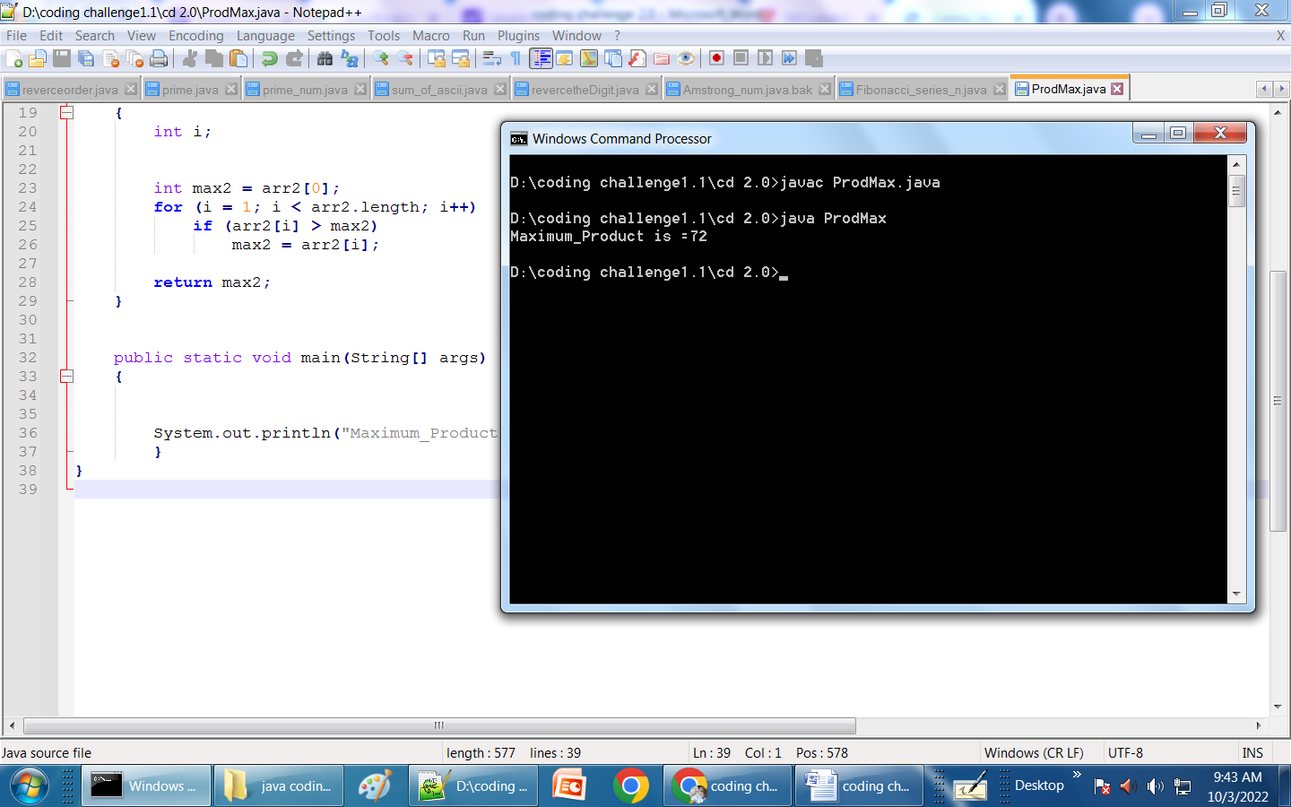

1. **Prime factorization: Create a prime factorization calculator that returns the prime factors of any number between 2 and 100. create a prime factorization calculator for any number.**

**PROGRAM:**

import java.util.Scanner;

public class PrimeFactors {

public static void main(String args[]){

int number;

Scanner sc = new Scanner(System.in);

System.out.println("Enter a number ::");

number = sc.nextInt();

System.out.println("The prime factor is:");

for(int i = 2; i< number; i++) {

while(number%i == 0) {

System.out.println(i+" ");

number = number/i;

}

}

if(number >2) {

System.out.println(number);

}

}

}

**OUTPUT:**

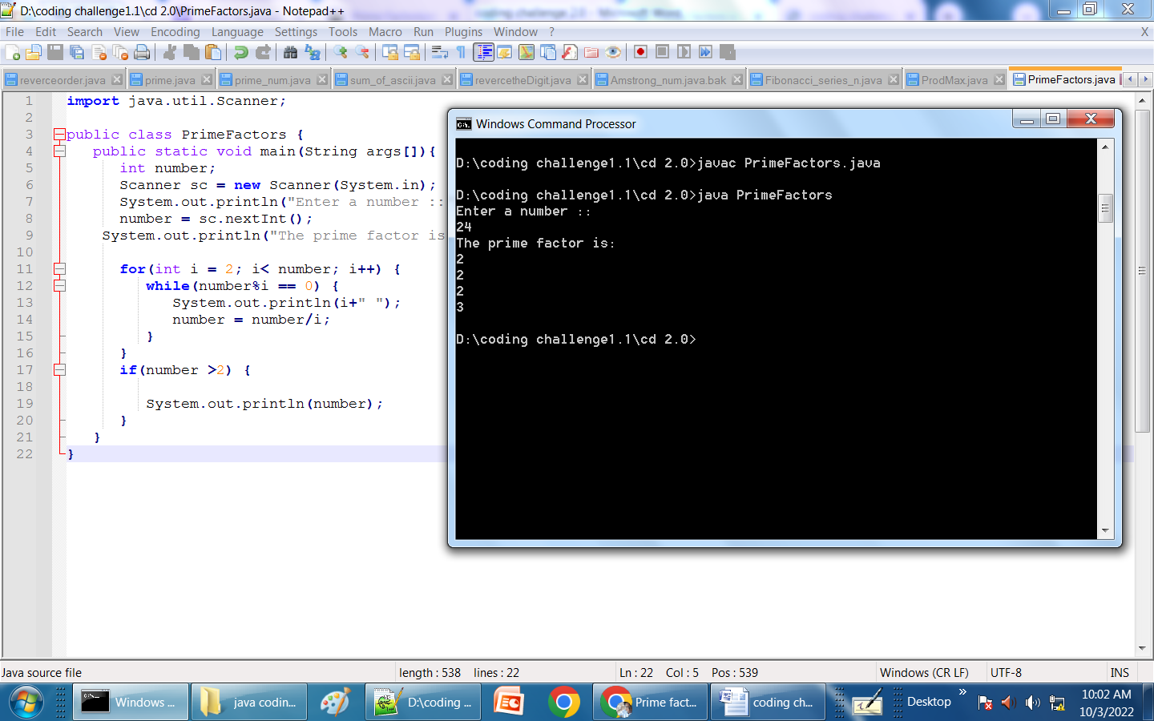

1. **Write a program which takes input as string and check if it is palindrome or not.**

**PROGRAM:**

import java.util.*;

public class Palindrome_or_not {

static boolean Palindrome(String str)

{

int i = 0, j = str.length() - 1;

while (i < j) {

if (str.charAt(i) != str.charAt(j))

return false;

i++;

j--;

}

return true;

}

public static void main(String[] args)

{

Scanner sc = new Scanner (System.in);

System.out.println("Enter the string:");

String str = sc.nextLine();

str = str.toLowerCase();

if (Palindrome(str))

System.out.print("Input string is a palindrome");

else

System.out.print("Input string is Not a palindrome");

}

}

**OUTPUT:**

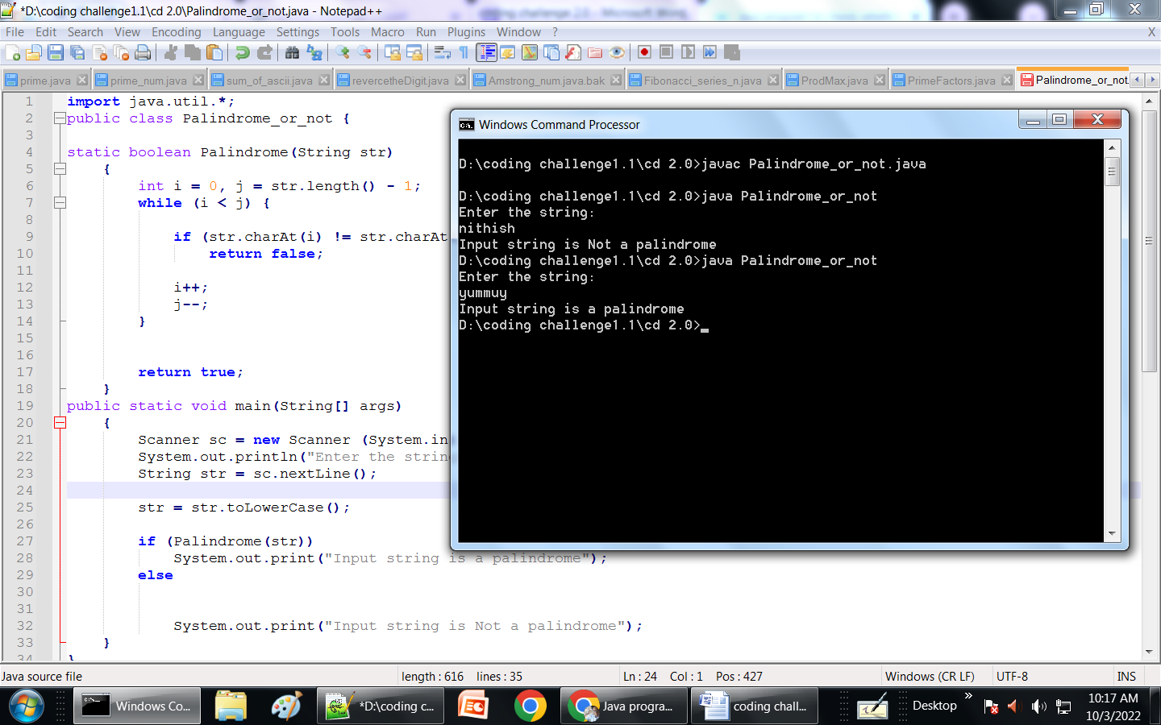

1. **Write a java program to get the age in years and find the age in days.**

**PROGRAM:**

import java.time.*;

import java.util.*;

public class age_in_days

{

public static void main(String args[])

{

LocalDate dob = LocalDate.of(2001, 01, 15);

LocalDate curDate = LocalDate.now();

Period period = Period.between(dob, curDate);

System.out.printf("Your age is %d years %d months and %d days.", period.getYears(), period.getMonths(), period.getDays());

}

}

**OUTPUT:**

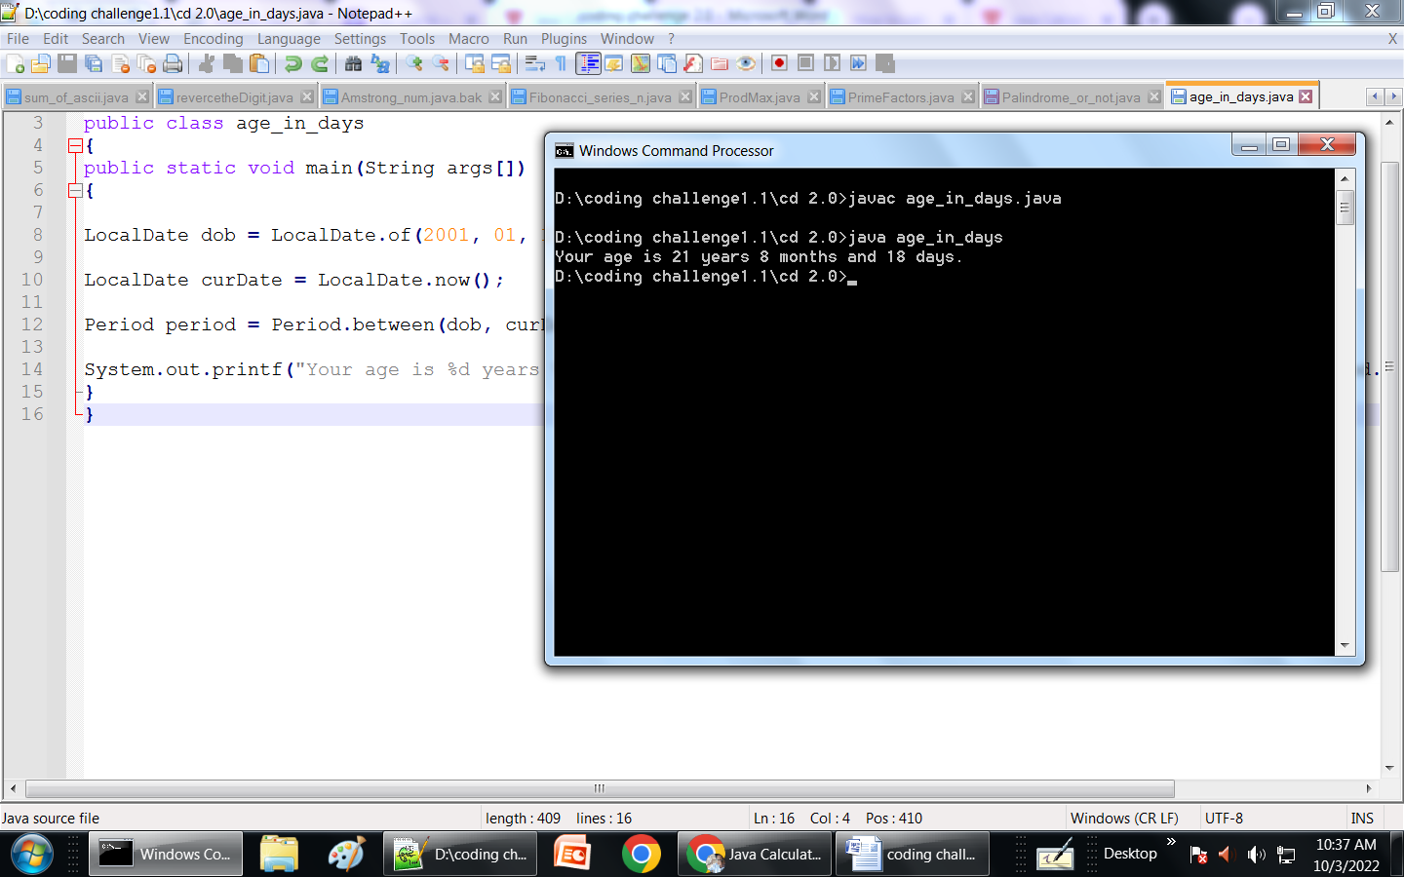

1. **Merge two strings S1 and S2 without duplicates.**

**PROGRAM:**

import java.util.*;

public class mergeTwoString {

public static String merge(String str1, String str2)

{

StringBuilder result = new StringBuilder();

for (int i = 0; i < str1.length() || i < str2.length(); i++) {

if (i < str1.length())

result.append(str1.charAt(i));

if (i < str2.length())

result.append(str2.charAt(i));

}

return result.toString();

}

public static void main(String[] args)

{

Scanner sc = new Scanner (System.in);

System.out.println("Enter the string 1:");

String str1 = sc.nextLine();

System.out.println("Enter the string 2:");

String str2 = sc.nextLine();

System.out.println(merge(str1, str2));

}

}

**OUTPUT:**

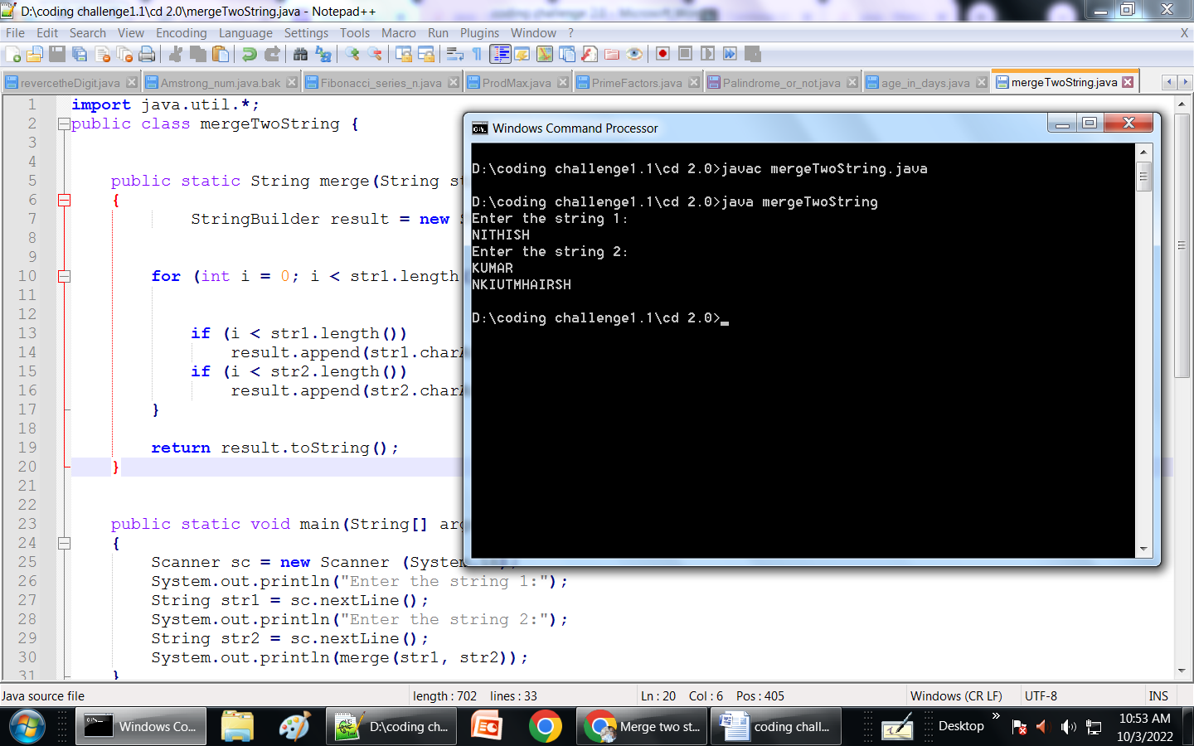

1. **Merge two arrays of strings with common characters.**

**PROGRAM:**

**Import java.util.ArrayList;**

**Import java.util.Arrays;**

**import java.util.List;**

**class Mergechar {**

**public static void main(String args[]) {**

**String s1[] = { "N", "I", "T","H","I","S","H" };**

**String s2[] = { "K", "U","M","A","R" };**

**List list = new ArrayList(Arrays.asList(s1));**

**list.addAll(Arrays.asList(s2));**

**Object[] merge = list.toArray();**

**System.out.println(Arrays.toString(merge));**

**}**

**}**

**OUTPUT:**

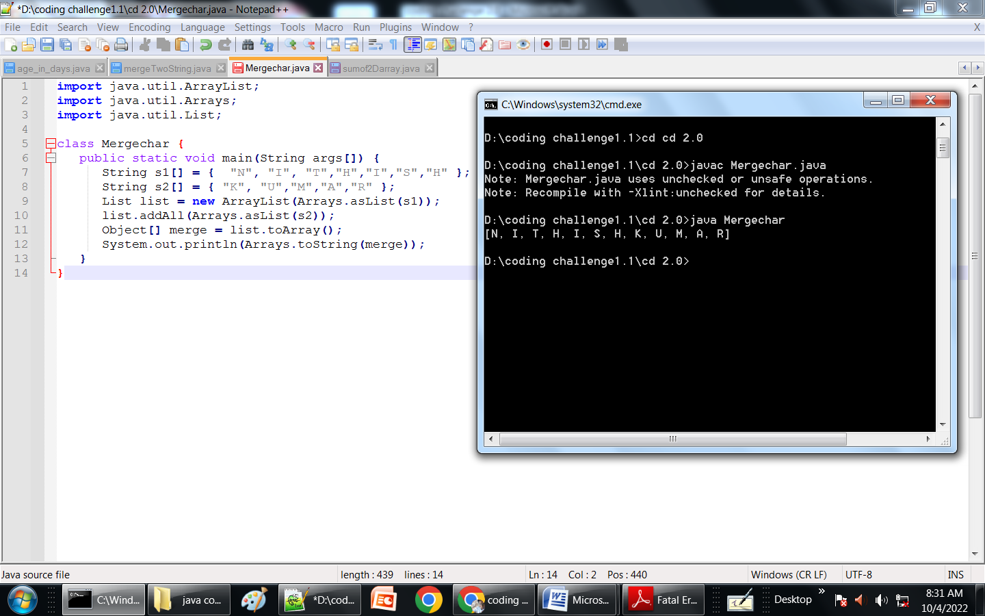

**7.Write a program to sum the given column values of a two dimensional array: arr={(1,2,3),(4,5,6),(7,8,9)}.**

**PROGRAM:**

import java.util.*;

public class sumof2Darray

{

public static void main(String args[])

{

//Original arrayarr={(1,2,3),(4,5,6),(7,8,9)}

int arr1[] = {1,2,3};

int arr2[] = {4,5,6};

int arr3[] = {7,8,9};

int resultantArr[] = new int[arr1.length];

for(int i=0;i<arr1.length;i++)

resultantArr[i] = arr1[i] + arr2[i]+ arr3[i];

printArray(resultantArr);

}

static void printArray(int arr[])

{

System.out.println("Sum the given column values");

for(int i = 0; i < arr.length ; i++)

System.out.print(arr[i]+" ");

System.out.println();

}

}

**OUTPUT:**

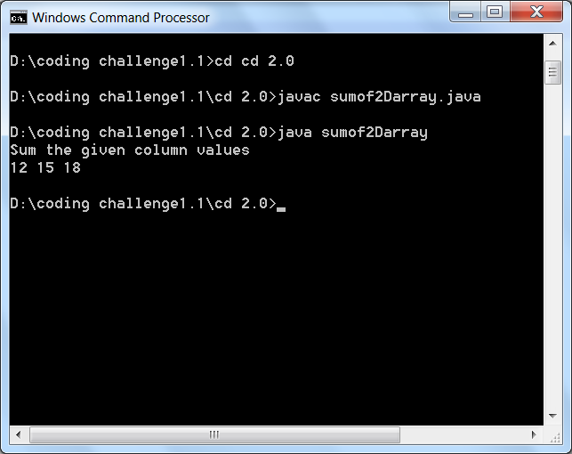

1. **Find and count the vowels and consonants of a given sentence: The program should calculate the sum of ascii values of the characters of each string.**

**PROGRAM:**

import java.util.Arrays;

import java.util.*;

class CountVC {

static long SumofASCIIchar(String str, long sumArr[])

{

int l = str.length();

int pos = 0;

long sum = 0;

long bigSum = 0;

for (int i = 0; i < l; i++) {

if (str.charAt(i) == ' ') {

bigSum += sum;

sumArr[pos++] = sum;

sum = 0;

}

else

sum += str.charAt(i);

}

sumArr[pos] = sum;

bigSum += sum;

return bigSum;

}

public static void main(String args[])

{

Scanner sc = new Scanner(System.in);

System.out.printf("Enter the string:");

String str = sc.nextLine();

int ctr = 0;

for (int i = 0; i < str.length(); i++)

if (str.charAt(i) == ' ')

ctr++;

long sumArr[] = new long[ctr + 1];

long sum = SumofASCIIchar(str, sumArr);

System.out.println("Sum of ASCII values:");

for (int i = 0; i <= ctr; i++)

System.out.print(sumArr[i] + " ");

System.out.println();

System.out.print("Sum of ASCII value of character :" + sum);

}

}

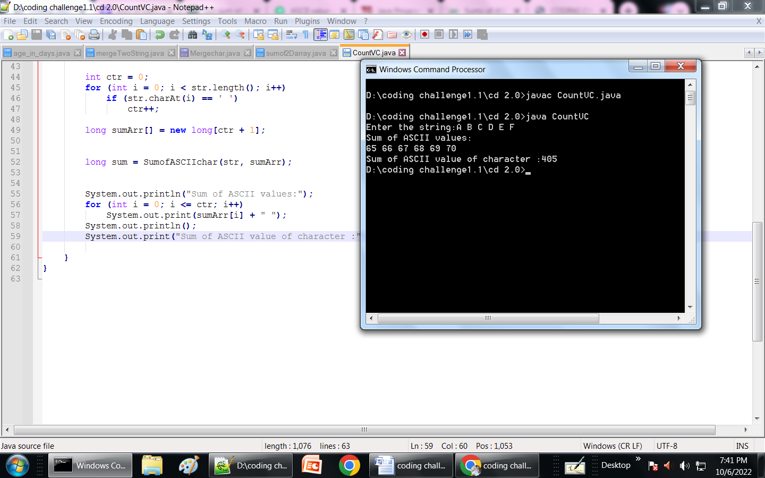

1. **Find and count the vowels and consonants of a given sentence: The program should calculate the sum of ascii values of the characters of each string.**

**PROGRAM:**

import java.util.Scanner;

public class CountVC

{

public static void main(String args[])

{

String str;

int vowCount=0,consCount=0;

Scanner scan=new Scanner(System.in);

System.out.print("Enter the String: ");

str=scan.nextLine();

int i=0;

for(i=0; i<str.length(); i++){

char ch=str.charAt(i);

if(ch == 'a'|| ch == 'e'|| ch == 'i'|| ch == 'o'|| ch == 'u'

||ch == 'A'|| ch == 'E'|| ch == 'I'|| ch == 'O'|| ch == 'U' ){

vowCount++;

}

else if((ch >= 'a' && ch <= 'z' || ch >= 'A' && ch <= 'Z' )){

consCount++;

}

}

System.out.println("Number of vowels: "+vowCount);

System.out.println("Number of consonants: "+consCount);

for(i = 0; i < str.length(); i++)

{

char ch = str.charAt(i);

int num = (int) ch;

System.out.println("The ASCII Value of " + ch +

" Character = " + num);

}

}

}

**OUTPUT:**

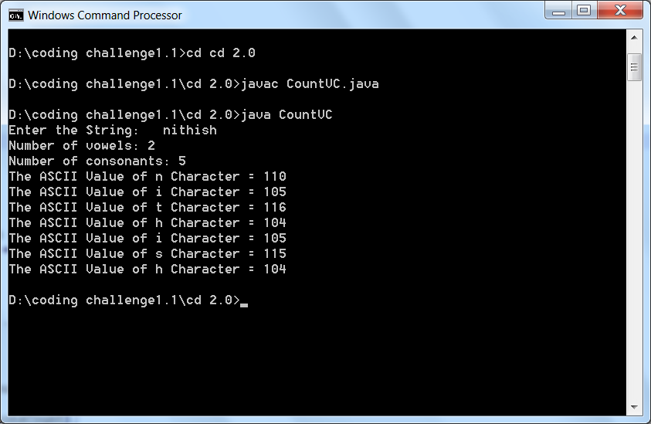

1. **Write a program to find the LCM of the given numbers: 45, 270**

**PROGRAM:**

class LCM{

public static void main(String[] args) {

int n1 = 45, n2 = 270, gcd = 1;

for(int i = 1; i <= n1 && i <= n2; ++i) {

if(n1 % i == 0 && n2 % i == 0)

gcd = i;

}

int LCM = (n1 * n2) / gcd;

System.out.printf("The LCM of %d and %d is %d.", n1, n2, LCM);

}

}

**OUTPUT:**

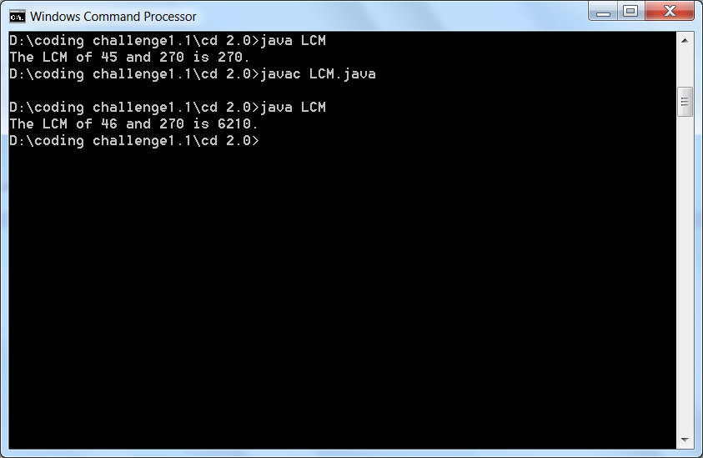

1. **Find the permutations of the given string: S=”KALANJIYAM”**

**PROGRAM:**

public class PermuteString{

static void printPermutn(String str, String ans)

{

if (str.length() == 0) {

System.out.print(ans + " ");

return;

}

for (int i = 0; i < str.length(); i++) {

char ch = str.charAt(i);

String ros = str.substring(0, i) +str.substring(i + 1);

printPermutn(ros, ans + ch);

}

}

public static void main(String[] args)

{

String s = "KALANJIYAM";

printPermutn(s, "");

}

}

**OUTPUT:**

